Dutch Open Coubertin Cup 2015
UIPM RANKING EVENT
Arnhem, The Netherlands

Version 2

Dear friends,

The Royal Netherlands Shooting Sport Association has the pleasure to invite a delegation from your country to participate in the Dutch Open Coubertin Cup 2015 (Modern Pentathlon, Tetrathlon and Triathlon).

The Dutch Open Coubertin Cup 2015 will take place in Arnhem, The Netherlands, on September 18th and 19th, 2015.
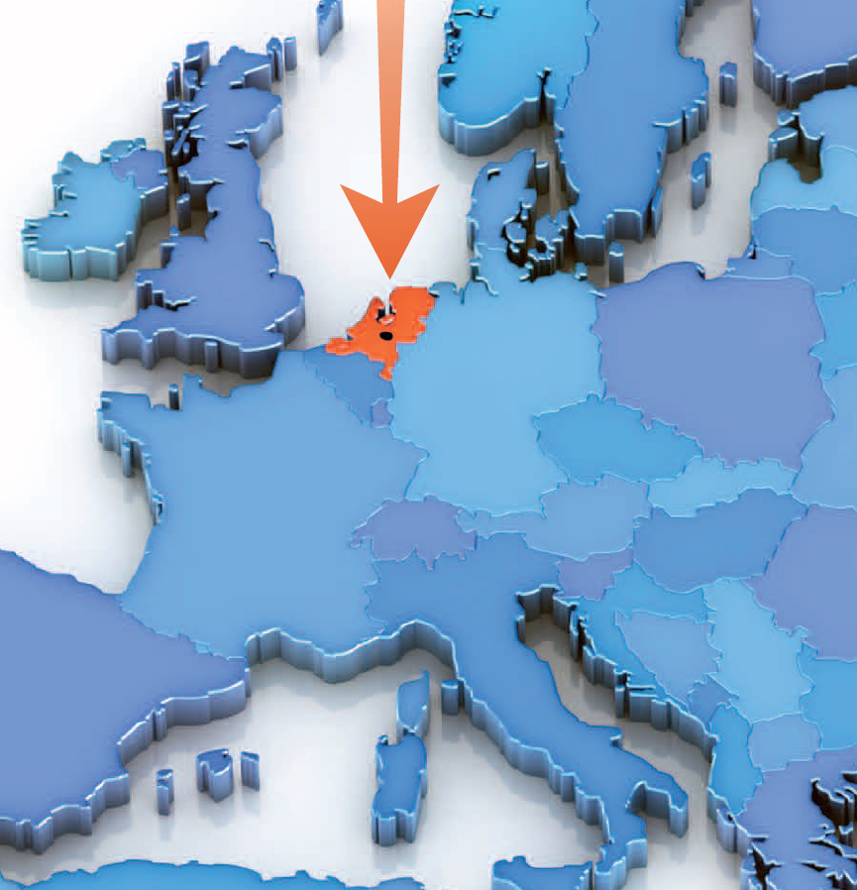
Arnhem, host city of the Dutch Open Coubertin Cup 2015

We are looking forward to welcome you to the Dutch Open Coubertin Cup 2015

National Sports Centre Papendal
Papendallaan 3
6816 VD ARNHEM
The Netherlands

SCHEDULE (All times to be confirmed):

Thursday September 17th
Arrival of Delegations
Friday September 18th
Swimming | 12.00–16.30
Fencing | 17.00–21.00
Saturday September 19th
Riding | 10.00-14.00
Combined | 15.00-18.00
Sunday September 20th
Departure of Delegations

COMPETITION RULES:
The competition will be carried out according to the UIPM Rules:

Swimming | 25 metre indoor swimming pool
Fencing | 6 + lanes
Riding | 1 show piste outdoor
Combined Run/Shoot | +/- 20 laser precision targets (UIPM approved)
 | Run part using athletics track

COMPETITION VENUE:
The competition will be held at two venues:

Friday September 18th
Swimming | Swimming pool “De Grote Koppel”  Olympus 25  6832 EL Arnhem
Fencing | Fencing club “Scaramouche”  Olympus 11  6832 EL Arnhem
Saturday September 19th
Riding | National Sportcentre Papendal  Papendallaan 4  6816 VD Arnhem
Combined

TRAINING:
The LOC will offer training moments before the relay. In the Technical meeting you will get informed.

TRANSPORT:
Attention: We offer two kinds of transport:

- Transport between the official hotels to the venues (€ 70,00 additional fee per day for transport and lunch)
- Transport from the official airport Schiphol-Amsterdam to the official hotels (additional fee € 100,00 P.P. only from official airport to official hotels)

Airport Schiphol-Amsterdam is located 100km from Arnhem where the venues and hotels are. From the Airport Schiphol-Amsterdam there is an excellent railway connection to Arnhem and when traveling by car, Arnhem and Sports centre Papendal can easily be reached. For teams choosing to fly into alternative airports or choose not to use the additional transport, will be responsible for arranging your own ground transportation accordingly. Car parking for teams can be arranged close proximity to the accommodation if agreed with the LOC in advance.

FINANCIAL CONDITIONS:
The costs for this competition are listed below.

Entry fee | € 80,00
Transport and lunch fee per day | € 70,00
Only from official hotel to venue
Additional fee
Transport Airport – official hotels | € 100,00
Only from airport Schiphol-Amsterdam

PAYMENT DETAILS :
All payments must be made via bank transfer in EUR and in accordance with the deadlines listed in the next section. The bank details are as follows:

Account Name: | KNSA
BIC | RABONL2U
IBAN | NL08RABO0105487023
Bank Name | Rabobank

The payee will be responsible for all bank charges incurred by KNSA for bank transfers and must select this option when making the payment. Payment reference It is important that you quote your National Federation Country Code and DOCC2015 as your payment reference for example: A payment from the Netherlands would have the reference: NEDDOCC2015.

DISCIPLINES:
Modern Pentathlon : Fencing – Swimming – Riding - Combined
Tetrathlon : Fencing – Swimming - Combined
Triathlon : Swimming - Combined

AGE CATEGORIES:
- Master (> 30 year)
- Senior (22-29 year)
- Junior (19-21 year)
- Youth A (17-18 year)
- Youth B (15-16 year)

* Male and female
* The category Master is not divided in age groups, but the handicap system will be taken into account.

RULES:
The event is organised according to the UIPM-rules

ADDITIONAL INFORMATION:
- According to UIPM-rules all participants must be a member of a national pentathlon federation or covering institution
- By registration Participants accept the rejection of all claims concerning liability, finance or other, lost properties, injuries and/or illness, etcetera. The participant has to take care of his/her own insurance(s)
- Included in the participation fee is the use of a horse. See for the extra fees and possibility’s at the financial conditions.
- There is no limit to the number of participants per country and no minimum or maximum of participants for the event.

TRAVEL AND LOGING:
The organization recommends three hotels: one situated at the accommodation of the National Sports Center Papendal, itself and one other is situated on at a 100 meters distance of the sports center and the last is situated in a few kilometres from the venue.

() 3-4: Hotel Papendal Arnhem
Papendallaan 3
6816 VD Arnhem, The Netherlands
www.papendal.nl
info@papendal-hotel.nl
(+31) 26 483 79 11

Hotel Van der Valk Arnhem
Amsterdamseweg 505
6816 VK Arnhem, The Netherlands
www.hotelarnhem.n
info@arnhem.valk.com
(+31) 26 482 11 00

Hotel Postillion Arnhem
Europaweg 25,
6816 SL Arnhem, Netherlands
http://www.postillionhotels.com/arnhem
hotel.arnhem@postillionhotels.com
(+31) 26 357 33 33

VISA AND VACINATION
Visiting participants should confirm visa and vaccination requirements for entry into the Netherlands prior to travelling to the event. For further information please contact your Embassy or Consulate. The Royal Netherlands Shooting Sport Association does not accept responsibility for arranging visas but will be able to provide letters of invitation, upon request.

CONTACT ORGANIZATION
For additional information please contact our Sports Development Assistent, Mr. Raymon Willemsen by e-mail: sportstimulering@knsa.nl or telephone: (+31)334601992.

